Name: ____________________

Precal 11 – Ch. 3 Review

1. How can you tell whether a function is a quadratic or not if you aren’t given its graph?

2. What is another word for “zero” of a function?

3. If the vertex is $(2,-3)$, what is a possible formula for the quadratic? (hint: there are many different answers here)

4. What is the equation for the axis of symmetry in the question above?

5. In the quadratic you formed in question 3, is it narrower or wider than the graph of $y=x^{2}$?

6. How does the graph of $y=x^{2}-5$ look compared to the graph of $y=x^{2}$?

7. How does the graph of $y={\left(x-3\right)}^{2}$ look compared to the graph of $y=x^{2}$?

8. How does the graph of $y=\frac{1}{2}{\left(x-2\right)}^{2}+1$ look compared to the graph of $y=x^{2}$?

9. Given a quadratic with the vertex $\left(2,2\right)$ and passing through the point $(1,0)$, what is the equation for the quadratic? What is the y coordinate when $x=3$?

10.What value of k will make $x^{2}+8x+k$ a perfect square trinomial?

11. Convert $y=x^{2}+10x+24$ to vertex form.

12. Convert $y=-4x^{2}+15x-36$ to vertex form

13. If the coordinate $\left(3,9\right)$ lies on the graph of $y=x^{2}$, what will be the coordinates of this point on the graph of $y=-3{\left(x+4\right)}^{2}-5$?

14. Graph the following parabolas without a graphing calculator. State the information required:

a) $y=-x^{2}+2$ b) $y=\frac{1}{4}{\left(x-3\right)}^{2}+6$

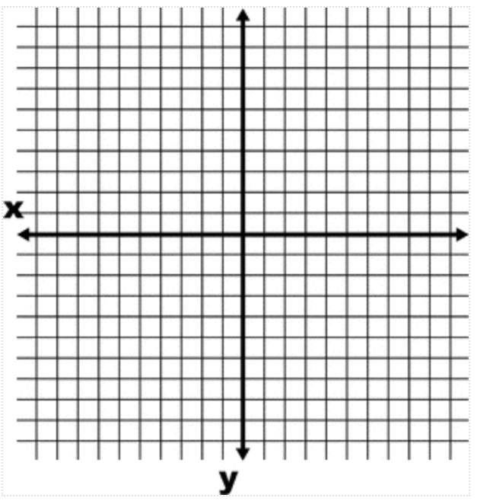
Vertex: ______________ Vertex: ______________

AOS: ___________ AOS: ___________

y-intercept: ______ y-intercept: ______

Domain: ______________ Domain: ______________

Range: ______________ Range: ______________

c) $y=x^{2}+3x-10$ d) $y=-x^{2}+8x+12$

Vertex: _________ Domain: ___________ Vertex: ______________ Domain: _________

AOS: ___________ Range: ____________ AOS: ___________ Range: ___________

y-intercept: ______ y-intercept: ______
15. Two numbers have a difference of 8 and the sum of their squares is a minimum. Determine the two numbers.

16. A bridge follows the shape of a downward facing parabola. The maximum depth is 2 m and the bridge is 10 m wide.

a) What quadratic function models the bridge if the vertex is at the origin?

b) What quadratic function models the bridge if the farthest left side is on the y-axis?

c) Using either of your quadratics, how high off the ground is a person standing 2 m onto the bridge?

17. You sell toy robots at $80. At this price, the company sells approximately 200 robots every week. For every $2 increase in price, the company will sell 3 fewer robots. At what price will the company yield the maximum revenue? Model this situation using a quadratic. Begin by using a “let” statement for your variables.

18. You have 100 m of fencing. You need to fence off 3 sides of a rectangle because your property is beside a lake. What is the maximum area of the property you are fencing?

19. Given the following points, find the quadratic equation in standard form that goes through these 3 points: $(-1,-9)$, $(0,-3)$, $(3,-33)$.

