Name: ______________________

Precal 11 – Ch. 4 Review

1. Factor the following:

a) $x^{2}+4x+3$ e) $3x^{2}+10x+7$

b) $x^{2}+2x-8$ f) $2x^{2}-9x+9$

c) $x^{2}-x-6$ g) $5{\left(x-1\right)}^{2}+12\left(x-1\right)+7$

d) $x^{2}-7x+12$ h) $169y^{2}-144x^{2}$

2. Solve the following by factoring

a) $3x^{2}-11x+10=0$ b) $6x^{2}-13x-5=0$

c) $5x^{2}-17x+6=0$ d) $3x^{2}+2x-8=0$

3. Solve the following by completing the square

a) $x^{2}+7x+12=0$ b) $x^{2}+9x+8=0$

d) $2x^{2}-15x+8=0$ e) $-4x^{2}+7x-9=0$

4. Solve the following using the quadratic formula

a) $2x^{2}-7x+6=0$ b) $9x^{2}-8x-1=0$

c) $5x^{2}-17x+6=0$ d) $4x^{2}+12x+5=0$

5. Solve the following using the method of your choice

a) ${\left(x-7\right)}^{2}={\left(x+3\right)}^{2}$ b) $\frac{1}{4}x^{2}-2x+7=0$

c) $25x^{2}+80x+61=0$ d) $\frac{1}{49}x^{2}-81=0$

6. How many roots does the quadratic $-4x^{2}+68x-120$have? Use the discriminant.

7. What values of k in the quadratic $4x^{2}-13x+k$yield

a) one real root

b) two real roots

c) no roots

8. The difference between the squares of two numbers is 75. One number is double the other. What is the product of the two numbers?

9. A ball is thrown upwards from a rooftop, 80 m above the ground. It will reach a maximum vertical height and then fall back to the ground. The height of the ball from the ground at time t is h, which is given by the function
$h\left(t\right)=-16t^{2}+64t+80$

a) What is the maximum height the ball reaches?

b) How long will it take for the ball to reach the ground?

c) What is the height of the ball at t=0?

d) How high is the ball after 4 seconds?

e) What are the domain and range of this situation?

10. The following picture shows the shape of a certain grass patch. If the area of the patch is $80m^{2}$, find k

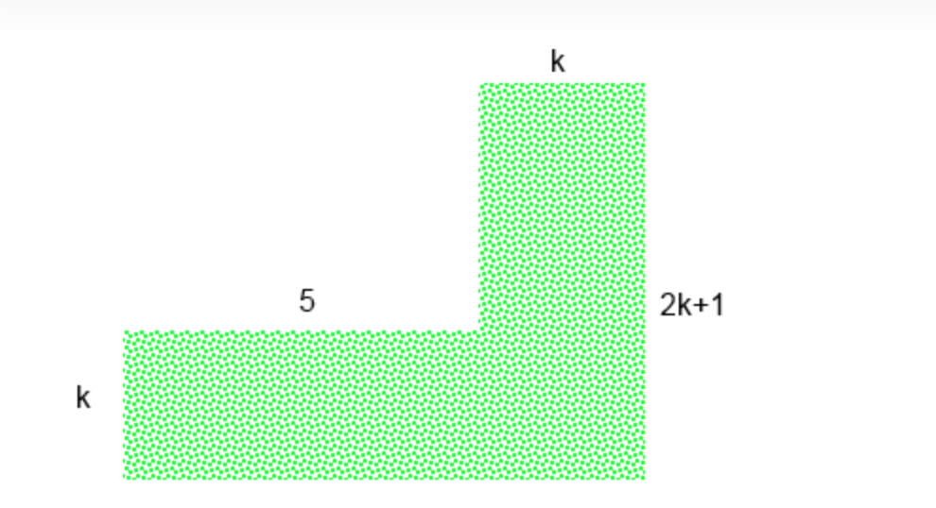

11. Three rods measure 20 cm, 41 cm and 44 cm. If the same length is cut off each piece, the remaining lengths can be formed into a right triangle. What length is cut off? (HINT: recall the Pythagorean theorem: $a^{2}+b^{2}=c^{2}$)

